**Cloud computing**

**Module -1**

**1. What is Cloud Computing?**

Cloud computing is the delivery of various services over the internet, including storage, processing power, and applications. Instead of owning and maintaining physical data centers and servers, businesses and individuals can access these resources on-demand from cloud service providers. This model allows for greater flexibility, scalability, and cost-efficiency.

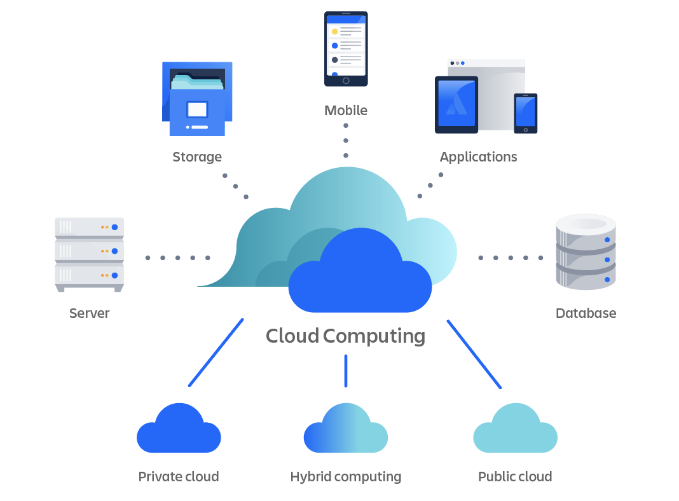

**2. Describe Cloud Computing Deployment Models**

Cloud computing deployment models define how cloud services are made available to users. There are several types:

Public Cloud: Services are delivered over the public internet and shared across multiple organizations. Examples include Amazon Web Services (AWS), Microsoft Azure, and Google Cloud Platform.

Private Cloud: Services are maintained on a private network, offering greater control and security. This model is often used by organizations with specific regulatory or security requirements.

Hybrid Cloud: Combines public and private clouds, allowing data and applications to be shared between them. This provides greater flexibility and optimization of existing infrastructure.

Community Cloud: Shared among several organizations with common concerns, such as security, compliance, or jurisdiction.

Multi-Cloud: Utilizes multiple cloud services from different providers to avoid dependency on a single provider and to optimize performance.

In addition to deployment models, cloud computing is categorized into different service models:

Infrastructure as a Service (IaaS): Provides virtualized computing resources over the internet. IaaS offers fundamental building blocks like virtual machines, storage, and networks. Users have control over the operating systems and applications but not the underlying infrastructure. Examples include AWS EC2 and Google Compute Engine.

Platform as a Service (PaaS): Offers hardware and software tools over the internet, typically for application development. PaaS provides a platform allowing customers to develop, run, and manage applications without dealing with the underlying infrastructure. Examples include Google App Engine and Microsoft Azure App Services.

Software as a Service (SaaS): Delivers software applications over the internet, on a subscription basis. SaaS providers manage the infrastructure and platforms that run the applications. Users access the software via a web browser. Examples include Google Workspace and Microsoft Office 365.

Function as a Service (FaaS): Also known as serverless computing, FaaS allows developers to execute code in response to events without managing servers. This model is highly scalable and cost-effective for event-driven applications. Examples include AWS Lambda and Azure Functions.

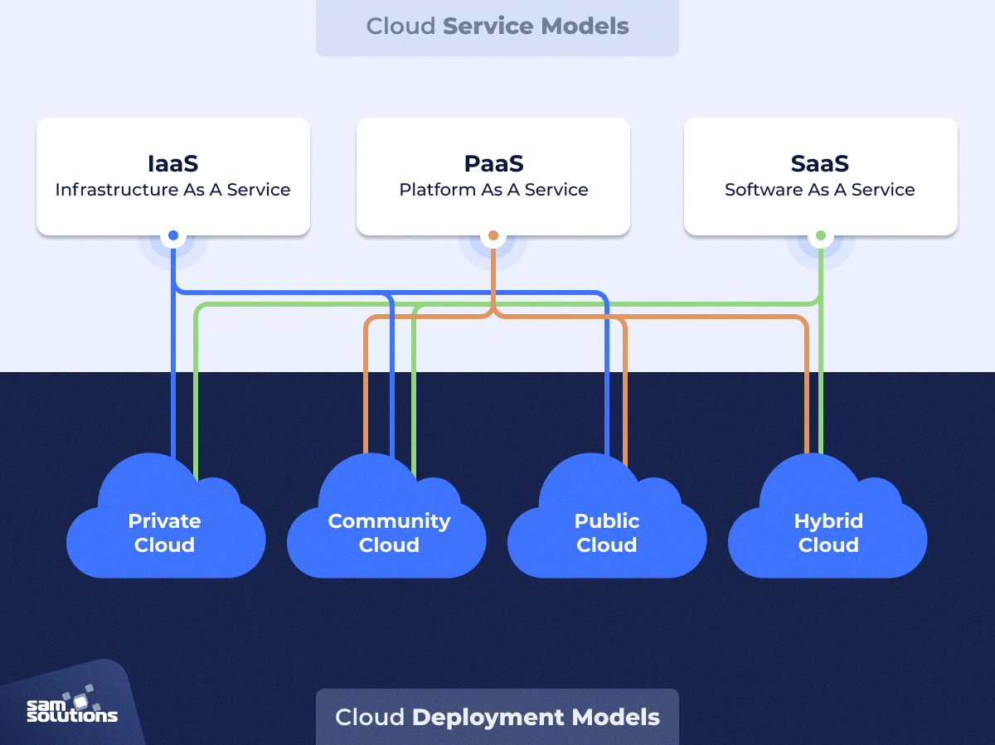

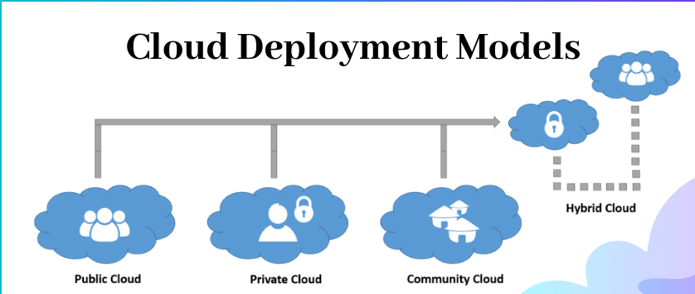

**3. What are Components of Cloud Computing?**

Cloud computing architecture consists of several key components:

Client Infrastructure: The front-end component that includes the user interface and client devices.

Application: The software or platform that users interact with.

Service: The core of cloud computing, which includes IaaS, PaaS, and SaaS.

Runtime Cloud: The execution environment for services.

Storage: Data storage capacity provided by the cloud.

Infrastructure: The physical and virtual resources that support the cloud services.

Management: Tools and processes for managing cloud resources.

Security: Mechanisms to protect data and applications in the cloud.

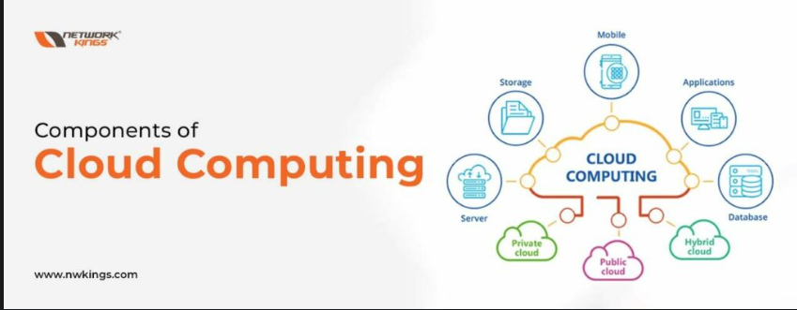

**4. Advantages and Disadvantages of Cloud Computing**

Advantages:

Cost Savings: Reduces the need for physical hardware and maintenance.

Scalability: Easily scale resources up or down based on demand.

Accessibility: Access services from anywhere with an internet connection.

Speed: Rapid deployment of resources and applications.

Backup and Recovery: Simplifies data backup and disaster recovery processes.

Automatic Updates: Cloud providers handle software updates and maintenance89.

Disadvantages:

Security Risks: Potential vulnerabilities and data breaches.

Downtime: Dependence on internet connectivity can lead to downtime.

Limited Control: Less control over infrastructure and data.

Cost Overruns: Pay-as-you-go models can lead to unexpected expenses if not managed properly.

